**Exercise 10: Implementing the MVC Pattern**

**Scenario:**

You are developing a simple web application for managing student records using the MVC pattern.

**Steps:**

1. **Create a New Java Project:**
   * Create a new Java project named **MVCPatternExample**.
2. **Define Model Class:**
   * Create a class **Student** with attributes like **name, id, and grade**.
3. **Define View Class:**
   * Create a class **StudentView** with a method **displayStudentDetails()**.
4. **Define Controller Class:**
   * Create a class **StudentController** that handles the communication between the model and the view.
5. **Test the MVC Implementation:**
   * Create a main class to demonstrate creating a **Student**, updating its details using **StudentController**, and displaying them using **StudentView**.

**CODE:-**

// Model Class

class Student {

    private String name;

    private String id;

    private String grade;

    public Student(String name, String id, String grade) {

        this.name = name;

        this.id = id;

        this.grade = grade;

    }

    // Getters and setters

    public String getName() { return name; }

    public void setName(String name) { this.name = name; }

    public String getId() { return id; }

    public void setId(String id) { this.id = id; }

    public String getGrade() { return grade; }

    public void setGrade(String grade) { this.grade = grade; }

}

// View Class

class StudentView {

    public void displayStudentDetails(String name, String id, String grade) {

        System.out.println("Student Details:");

        System.out.println("Name  : " + name);

        System.out.println("ID    : " + id);

        System.out.println("Grade : " + grade);

    }

}

// Controller Class

class StudentController {

    private Student model;

    private StudentView view;

    public StudentController(Student model, StudentView view) {

        this.model = model;

        this.view = view;

    }

    public void setStudentName(String name) {

        model.setName(name);

    }

    public String getStudentName() {

        return model.getName();

    }

    public void setStudentId(String id) {

        model.setId(id);

    }

    public String getStudentId() {

        return model.getId();

    }

    public void setStudentGrade(String grade) {

        model.setGrade(grade);

    }

    public String getStudentGrade() {

        return model.getGrade();

    }

    public void updateView() {

        view.displayStudentDetails(model.getName(), model.getId(), model.getGrade());

    }

}

// Main Class to Test the MVC Pattern

public class MVCPatternExample {

    public static void main(String[] args) {

        // Create the model

        Student student = new Student("Sandeep", "241004263", "O");

        // Create the view

        StudentView view = new StudentView();

        // Create the controller

        StudentController controller = new StudentController(student, view);

        // Display initial data

        controller.updateView();

        // Update model data via controller

        System.out.println("\nUpdating student grade to A+...");

        controller.setStudentGrade("A+");

        // Display updated data

        controller.updateView();

    }

}

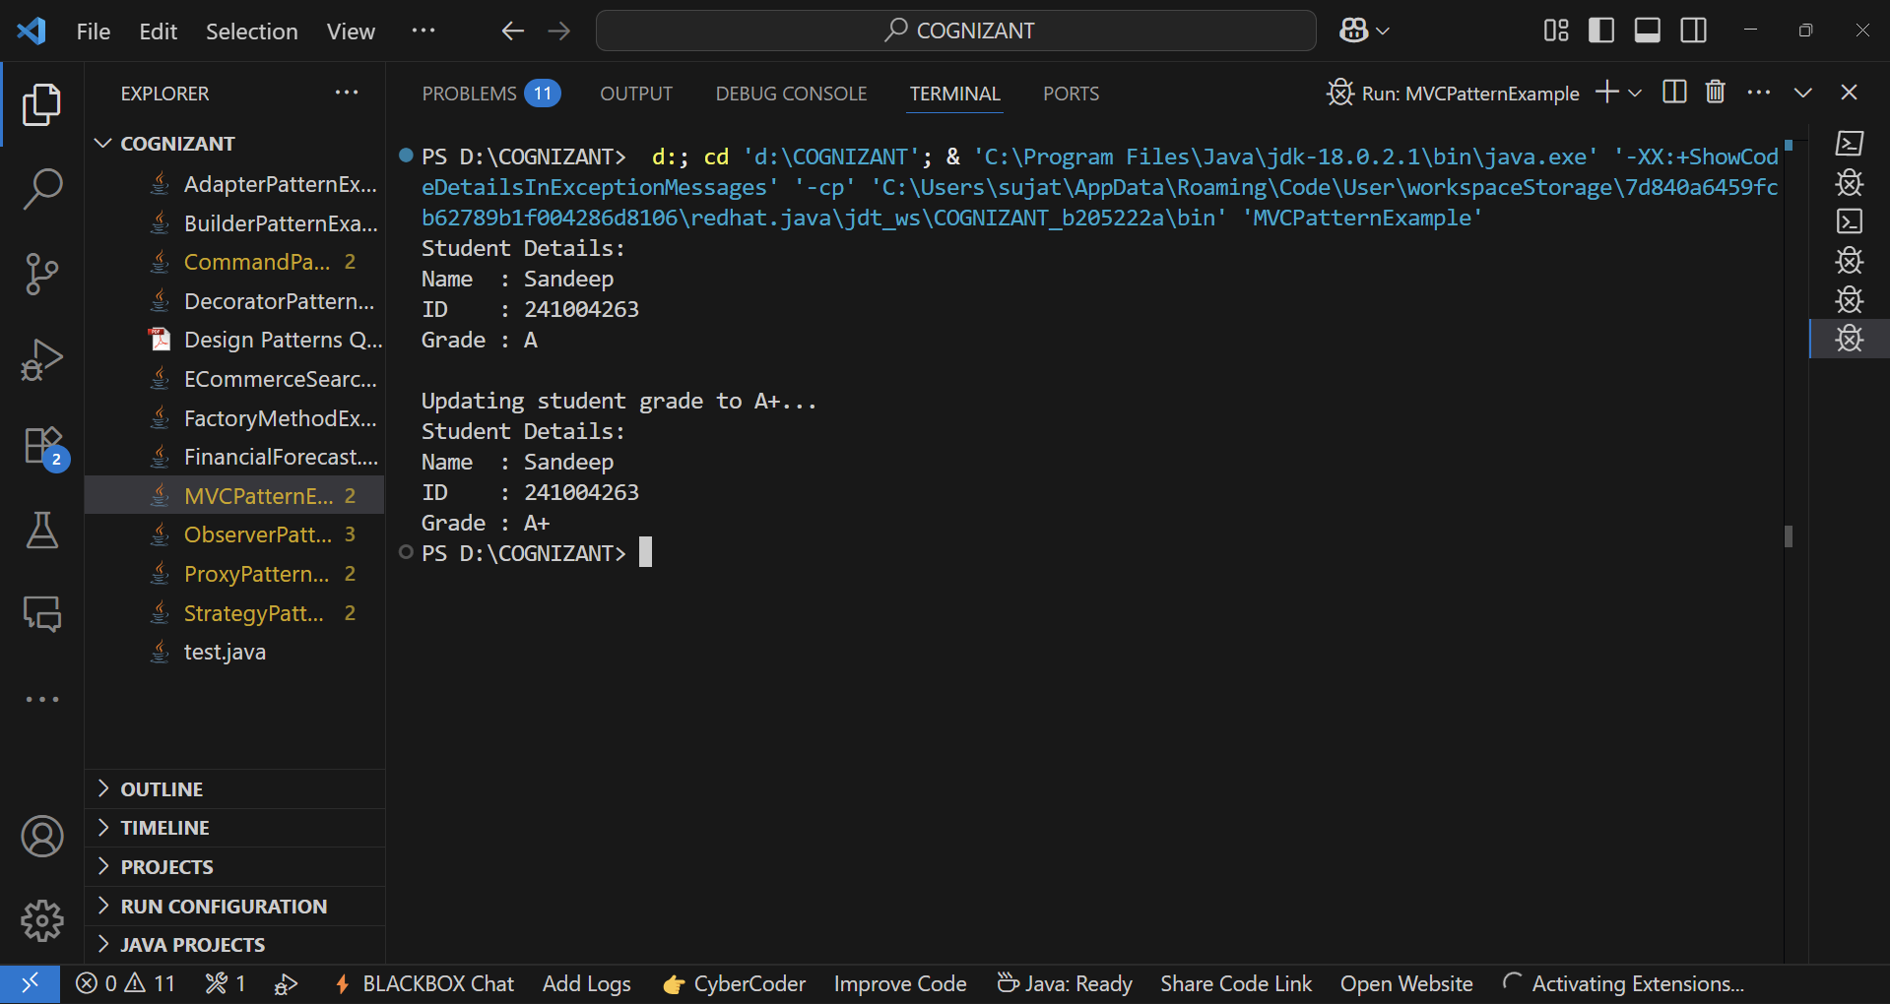**OUTPUT:-**